Growth Chart Import Specification

In Epic, all the growth chart reference data (from CDC, WHO, etc.) is on the server. In order for customers to use their own reference data set, the following provides information on how to import data from an Excel™ spreadsheet.

There are 3 steps in this import:

1. Write the data from spreadsheet to a formatted text file.
2. FTP the text file onto the server.
3. Run the import specification GROWTH CHART IMPORT from the HGC (growth chart) master file.

**1. Data format in Excel file:**

The excel file should look at this:

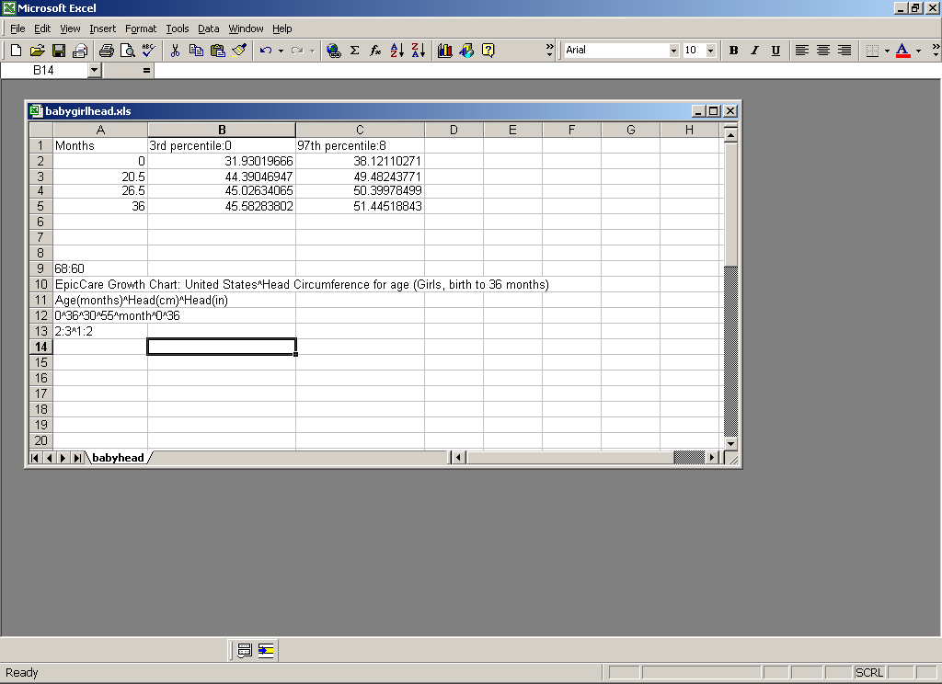

The first part is the data in metric unit (i.e. in cm or kg). The first column needs to be value for X-axis. The first row is the percentile and the color for that percentile (color will show up on screen). The percentile and the color is separated by “:”. The percentile MUST start with a number, i.e. “3rd percentile”, CANNOT be “the 3rd percentile”. The colors are:

|  |  |
| --- | --- |
| 0 – Black | 8 - Gray |
| 1 – Blue | 9 - Light Blue |
| 2 – Green | 10 - Light Green |
| 3 – Cyan | 11 - Light Cyan |
| 4 – Red | 12 - Light Red |
| 5 – Magenta | 13 - Light Magentas |
| 6 – Yellow | 14 - Light Yellow |
| 7 – White | 15 - Bright White |

The second part is 5 consecutive rows for legend information.

1. GRAPH WIDTH (AS a percentage of page/screen width): PrinterWidth : ScreenWidth
2. TITLES: Main title ^ Graph Title
3. AXIS LABELS: Bottom^ Left ^Right (The left will in metric unit, the right will be English unit for head circumference, length, weight, weight-length graphs. Both left and right labels will be in metric for BMI graph)
4. AXIS RANGES: Min X^Max X^Min Y^Max Y ^ Data in Month or Year ^ min age ^max age ( the min and max age is particularly useful for the weight over height graph, since the age is not explicitly defined on the graph.)
5. GRID/LABELLING: XRes:XLabel^YRes:YLabel

X/YRes: specify at what interval you want grid lines drawn.

X/YLabel: specify how many grid lines to skip between labels.

For example, 1^2:.5^4 draws a vertical line at each unit on the X-Axis and labels every other one. Also a horizontal grid line is drawn at every 1/2 unit up the Y-Axis and every fourth line are labeled.

**2. Running the Macro from Excel:**

The macro looks like:

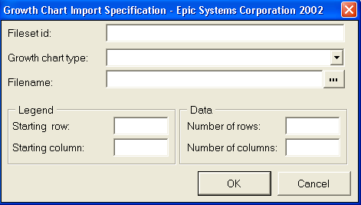

Input the following:

1. Name of the text file, type of the growth chart (Weight for age, BMI, etc.),
2. Number of columns and rows of the data. For the data in the figure above, the row number is 5, column number is 3. (Both row and column numbers are 1 greater than the actual value to include the headers)
3. Starting position of the legends. For the above figure, the row is 9, column is 1.

**3. From Text file to Packed Global:**

1. FTP the text file onto the server.
2. Run the import specification GROWTH CHART IMPORT from the HGC master file.
3. In Chronicles, navigate to Growth Chart Fileset Masterfile > Enter Data > Import Filesets > Import Data.
4. At the Import Specification prompt, enter GROWTH CHART IMPORT (or HGC,1000).
5. Enter the number of days to save the log for the import.
6. At the Source File prompt, enter the text file location on the server (i.e., /epic/epictemp/obesitybmifemale1.txt).
7. Enter the initial contact date.
8. Enter Yes at the Continue with Import Processing?
9. At the Chronicles Import Menu, select View Most Recent Log. Confirm that the record was processed:

Growth Chart Fileset Masterfile

Print Import Log

12/20/2012 1:20 PM Begin processing of database import

12/20/2012 1:20 PM Entry Person: 104631-MCDOUGALL, NOLA

12/20/2012 1:20 PM Data Source: File "/epic/epictemp/obesitybmifemale3.txt"

12/20/2012 1:20 PM Import Specification: HGC,1000

12/20/2012 1:20 PM Log purge date: 1/3/2013

12/20/2012 1:20 PM End of processing of database import; 1 records processed